`

Bosque Ecosystem Monitoring Program
Black Institute for Environmental Studies at Bosque School

The Urban Flood Demonstration Project
September 2014
1
www.bosqueschool.org/bemp.aspx

Summer Interns & Artists!

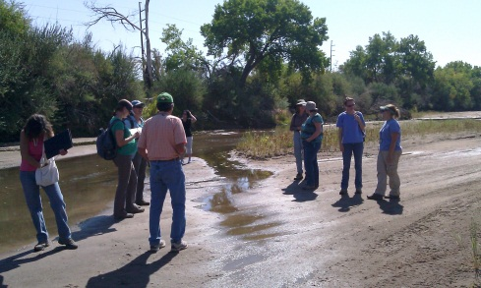

This summer we hired two GREAT high school summer interns, Carlos Villarreal from South Valley Academy and Maddie Lowry from the Albuquerque Academy. They started the job off during the hottest week of the year, with several days reaching 103°F! They battled unusually thick swarms of mosquitoes while sampling groundwater chemistry, collecting monthly monitoring data, setting and collecting arthropod pitfall traps, measuring accumulated woody debris, trimming trails and helping to install 5 groundwater wells at the NEW State Land Office site! Their work in the field was mirrored with just as much enthusiasm in the lab while sorting litterfall, identifying arthropods, and entering data.

Thank you Carlos
and Maddie for
all your help you
both ROCK!!!

By: Kim Fike, UNM graduate student & BEMP Field/Lab Assistant and Educator

BEMP is also excited to release summer artist Melina Baron-Deutsch’s zine Have you been to the Bosque? With text in both English and Español – this zine encourages its readers to create their OWN artistic impression of the bosque. Explaining what a bosque is, changes that we’ve made to the river, how to keep it clean and finally how to make your OWN zine.

Check out our BEMP
education & outreach website
to download this foldable
pdf for FREE!

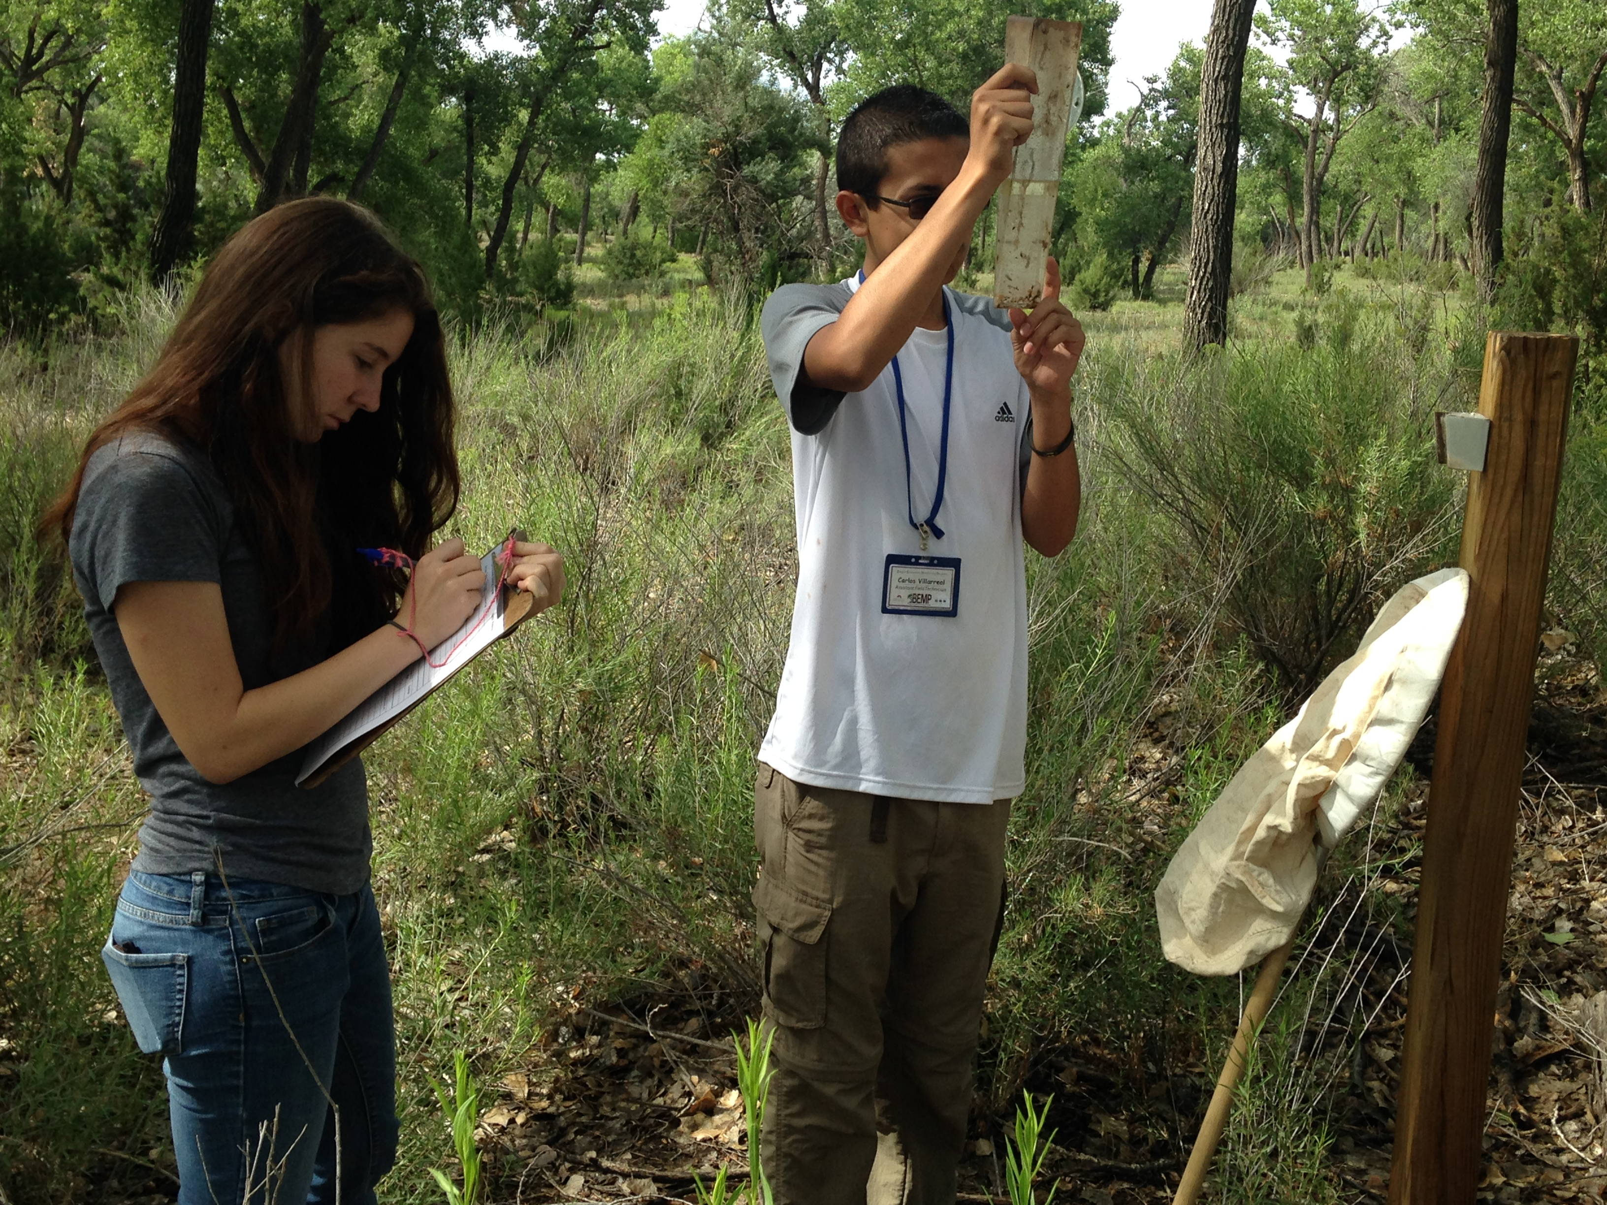

High schoolers Maddie and Carlos worked with BEMP UNM staff Kim Fike to continue summer data collections of leaf litter, pitfall traps, precipitation gauges, groundwater wells, water chemistry. They also help with site maintenance and more!
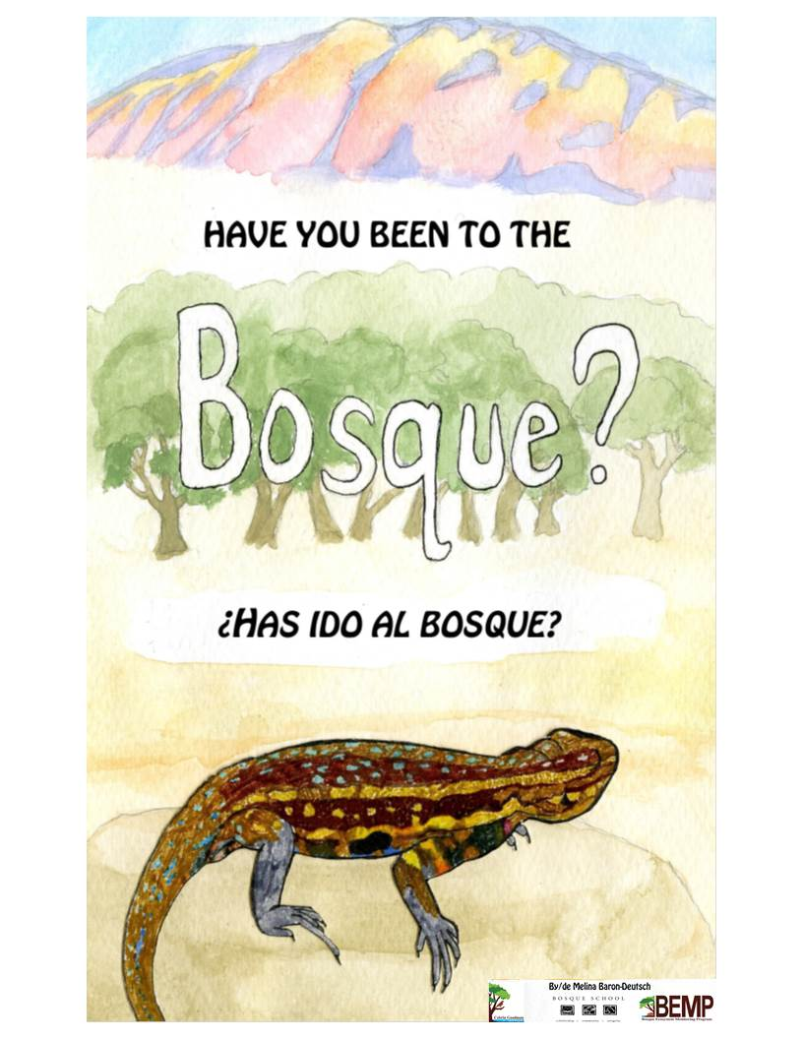

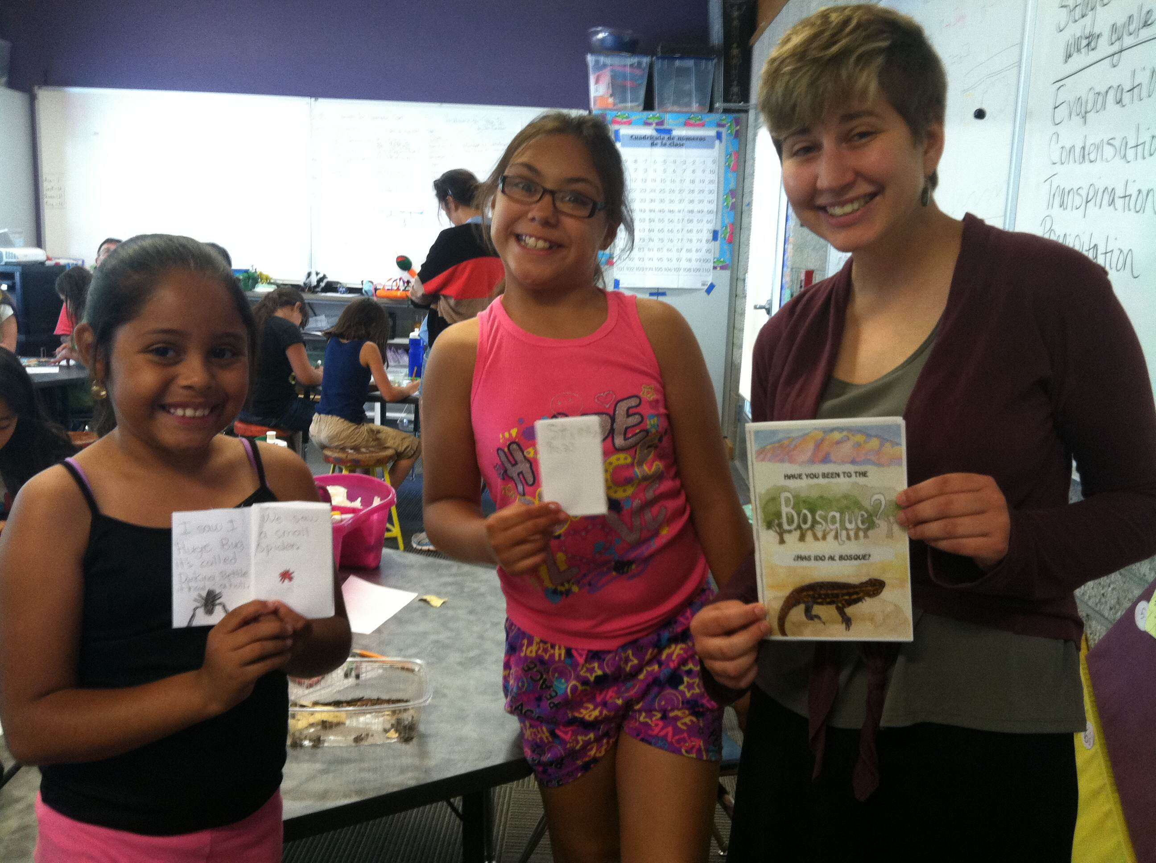

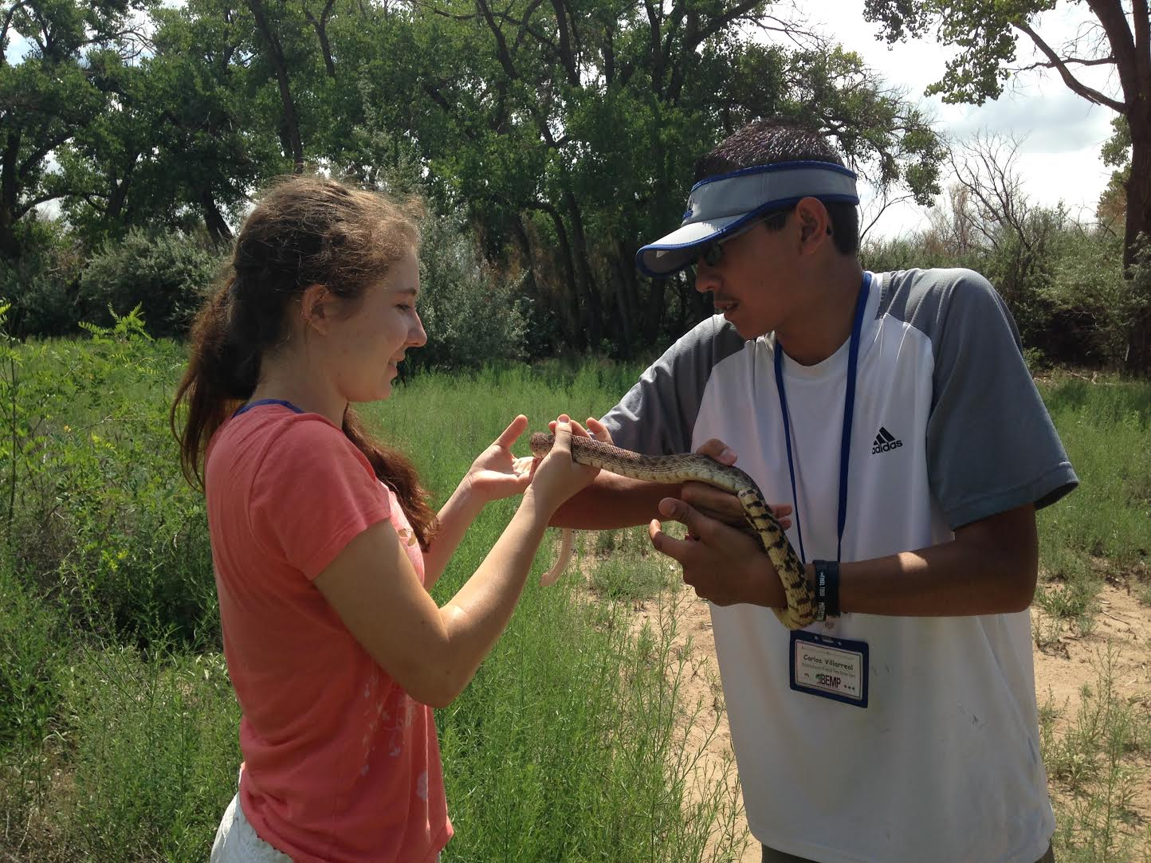

BEMP summer college artist Melina Baron-Deutsch (below on right) worked to create BEMP’s first bilingual ‘zine’! Melina shared her creation with Horizons summer students.

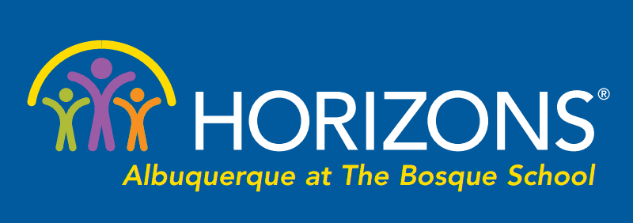

Story and pictures from: Juaquin Moya, Horizons Executive Director

Horizons Albuquerque at The Bosque School (Summer 2014) offers public school students academic support and builds students' confidence. Being on the Bosque School's campus is magical and encourages a love of learning. Our implementation of BEMP set Horizons at Bosque School apart as the first Horizons affiliate to offer an environmental science curriculum with an outdoor lab in the bosque and on Bosque's campus.

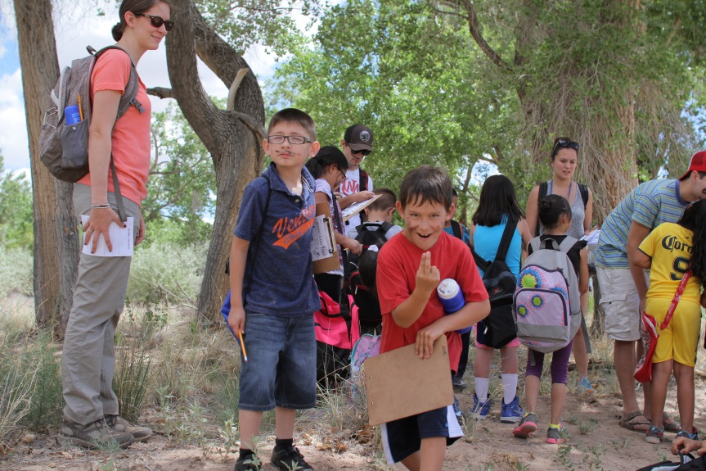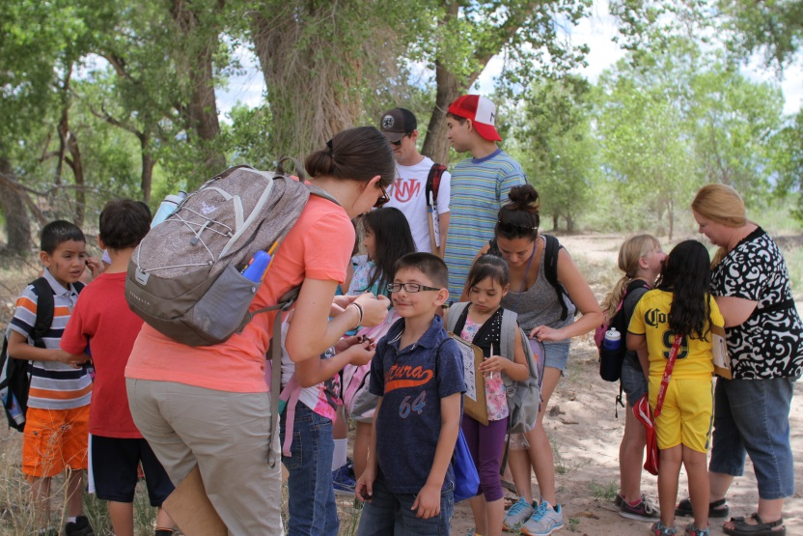

I was the first in my family to leave the state and graduate from college. A bit of serendipity and a lot of important role models helped me access higher education, and I know it was my time away from home that allowed me to find my own voice and gave me a better understanding of and a better appreciation for New Mexico. I've always dreamed of starting a non-profit that would improve access to education and equity. My background in both the public and private schools, as well as my passion for bringing the community together made the Horizons model an ideal fit. I was drawn to Horizons because it is a collaboration between independent and public schools; focuses on high quality academic instruction and student development; has a nutrition and health component, as well as provides breakfast, lunch, and a snack; and honors dedicated teachers, mentors younger teachers, and nurtures positive parent involvement. Horizons also requires swim lessons for each Horizons student; I swam competitively in college and intrinsically understand the value this life-long sport has in making a difference in a young person’s life.

THE SUMMER HORIZONS PROGRAM FEATURES:

• 14-16 students per class, led by a lead teacher, assistant teacher and junior teacher
• Classes in reading/literacy, math, science, using hands-on, project based learning
• Outdoor classroom along the Rio Grande with BEMP
• Swimming lessons, tennis lessons and soccer lessons
• Art, music, poetry, and computer lab experience
• Weekly field trips, two nutritious meals a day and daily bus transportation
• Professional development for Horizons Teachers in partnership with the Sofia Center
• Parent Workshops
LEARN MORE at: www.bosqueschool.org/horizons-albuquerque-1.aspx

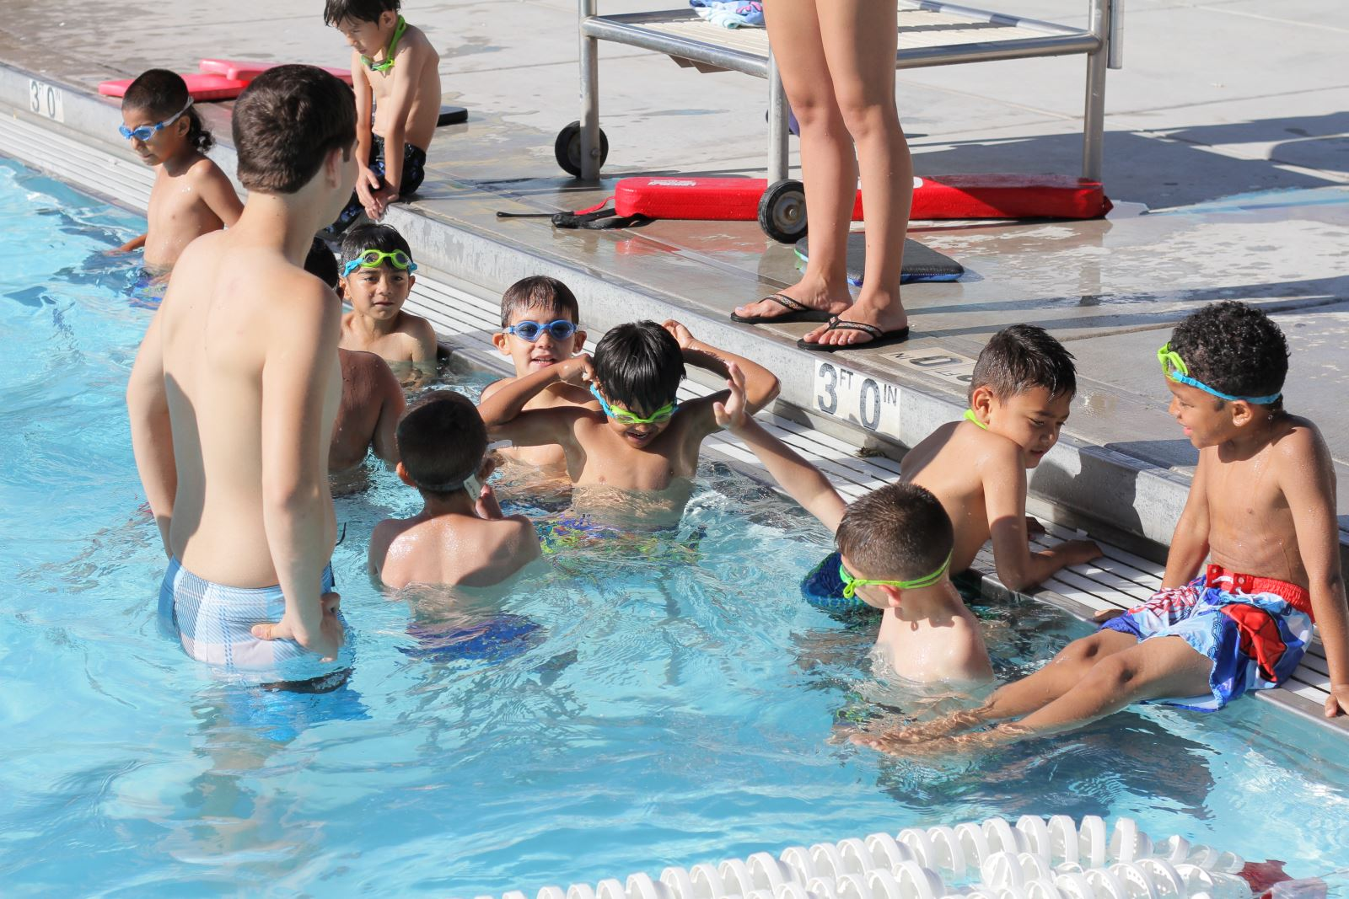
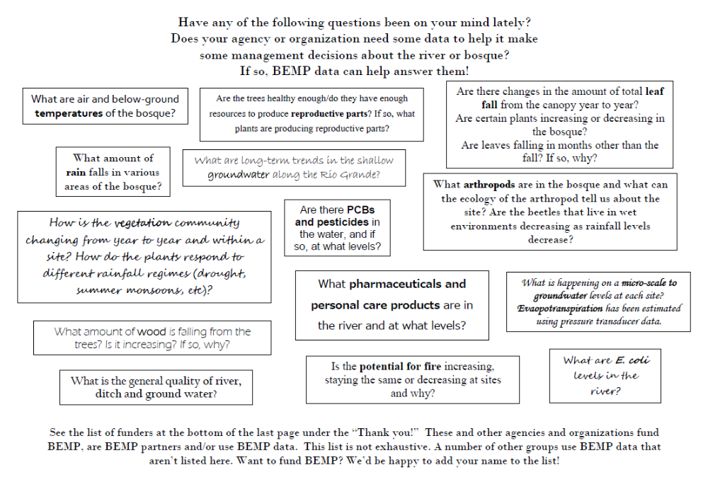

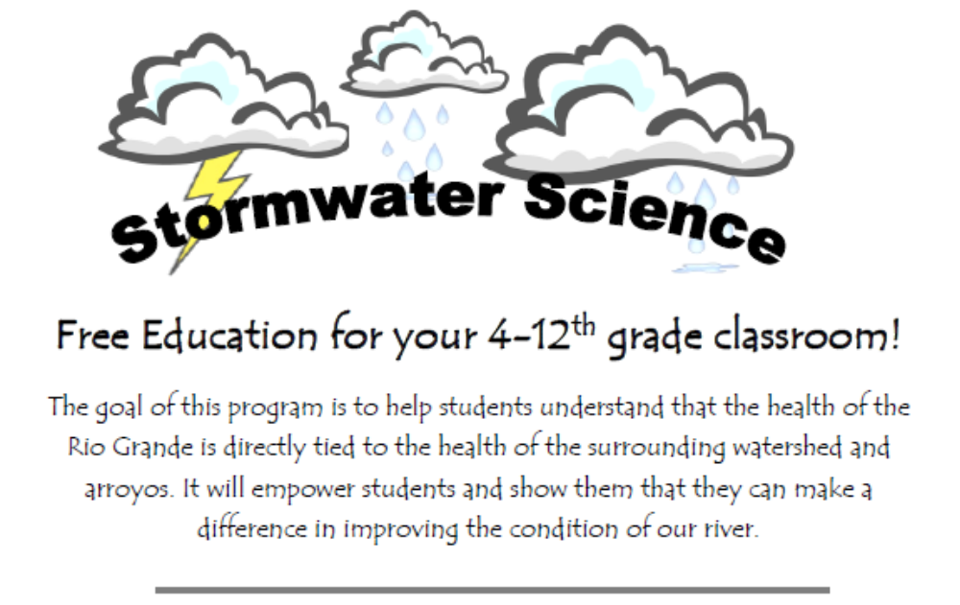
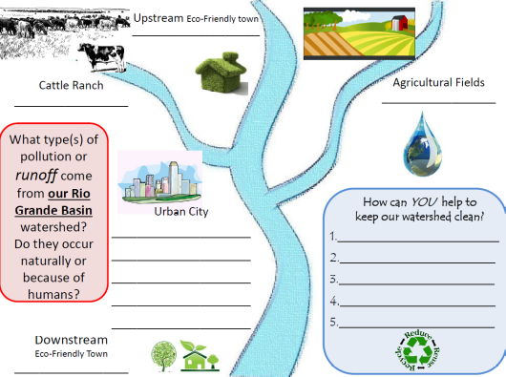

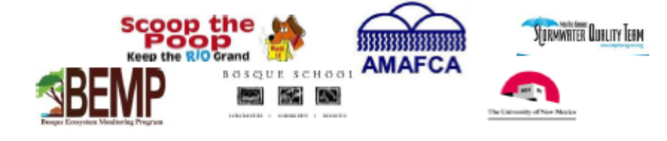
Schedule a Stormwater Science class with your students on a TUESDAY this 2014-2015 school year.
Connect with BEMP Educator Kelly Steinberg at:

Kelly.steinberg@bosqueschool.org or 505.898.6388 ext. 151

Project WET
New Mexico teachers get creative…

THANK YOU
THANK YOU
THANK YOU
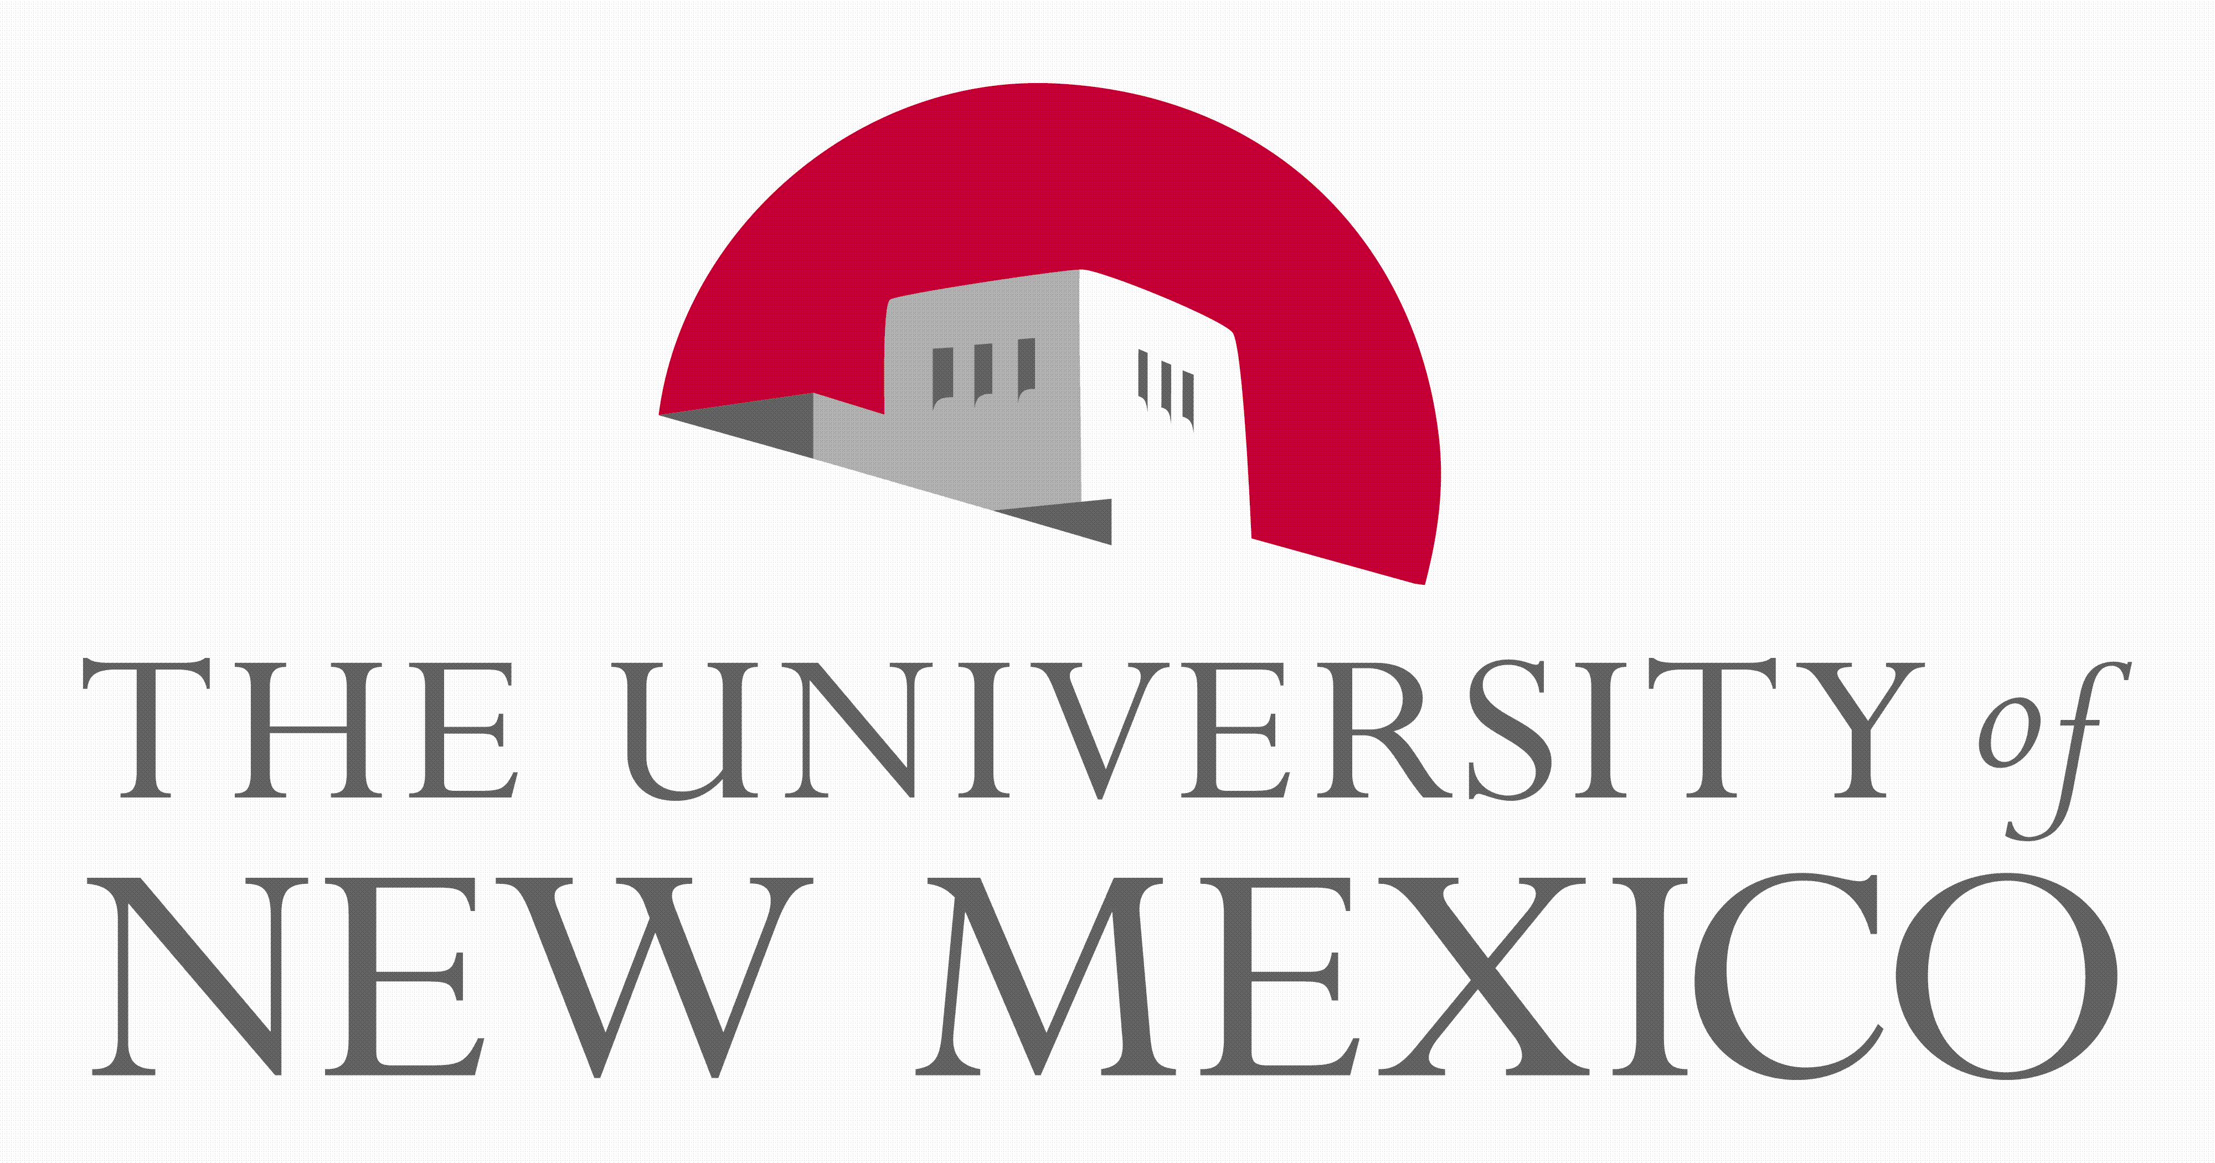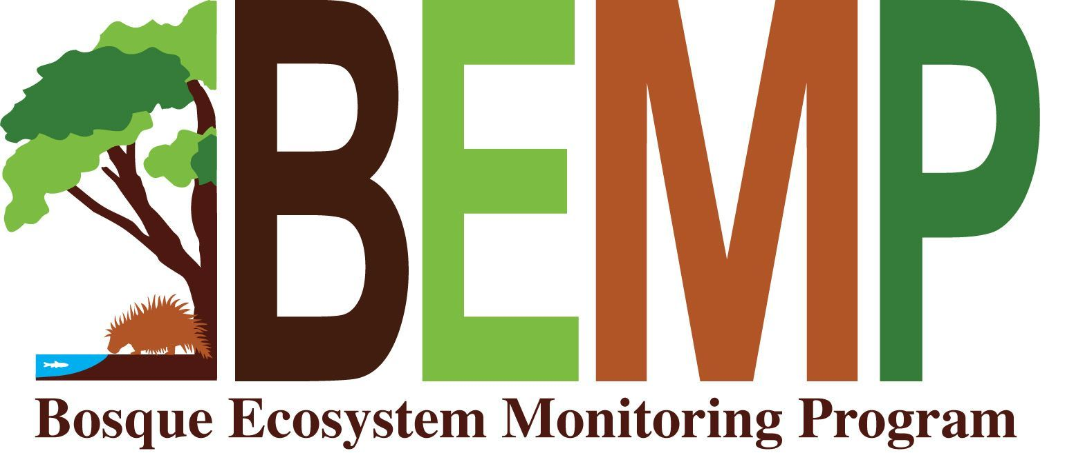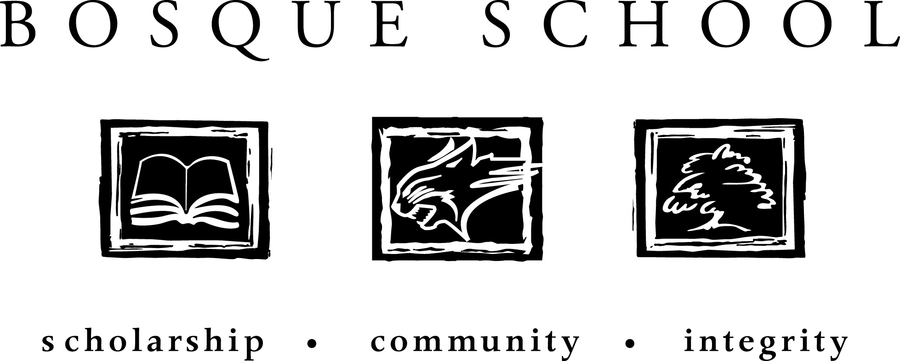

to those that sponsor BEMP
Albuquerque Community Foundation ♦ Bernalillo County Open Space ♦ Bosque School ♦ Greater Rio Grande Watershed Alliance ♦ Goodman Family ♦ LANL Foundation ♦ McKee/Crawford Foundation ♦ Middle Rio Grande Conservancy District ♦ McCune Charitable Foundation ♦ Mid Rio Grande Stormwater Quality Team (AMAFCA; Bernalillo County; City of Albuquerque; CUIDAD Soil & Water Conservation District; NM Dept. of Transportation; SSCAFCA & the Town of Bernalillo) ♦ National Science Foundation’s Schoolyard Education Program at UNM’s Sevilleta Long Term Ecological Research Site ♦ New Mexico Association of Soil & Water Conservation Districts ♦ New Mexico State Parks ♦ Sandoval County ♦ The Nature Conservancy ♦ U.S. Army Corps of Engineers ♦ U.S. Bureau of Reclamation ♦ USDA Forest Service

*Printed on recycled paper by Minuteman Press*

OUR MISSION

The mission of the Bosque Ecosystem Monitoring Program (BEMP) is collaborative long-term ecological monitoring of key abiotic and biotic processes and characteristics to promote continued education, understanding and stewardship of the riparian ecosystem to scientists, teachers, students, policy makers and the public.
BEMP and the Environmental Education Association of New Mexico (EEANM) worked together on Sept. 6th to co-host a Project WET teacher workshop on the Bosque School campus. Classroom teachers and informal educators from around the state gathered to learn fun, hands-on ways to teach and integrate water into their curriculum. With team teachers, Cass Landrum and Barbara Garrity with EEANM, and Kimi Scheerer with BEMP, educators discovered the role of macro-invertebrates (even wading into the pond as a finale), had adventures in density and even created water laden human body drawings. Each teacher received a Project WET Curriculum and Activity Guide 2.0, a BEMP pocket naturalist guide and even a sampling of basil from the school garden!

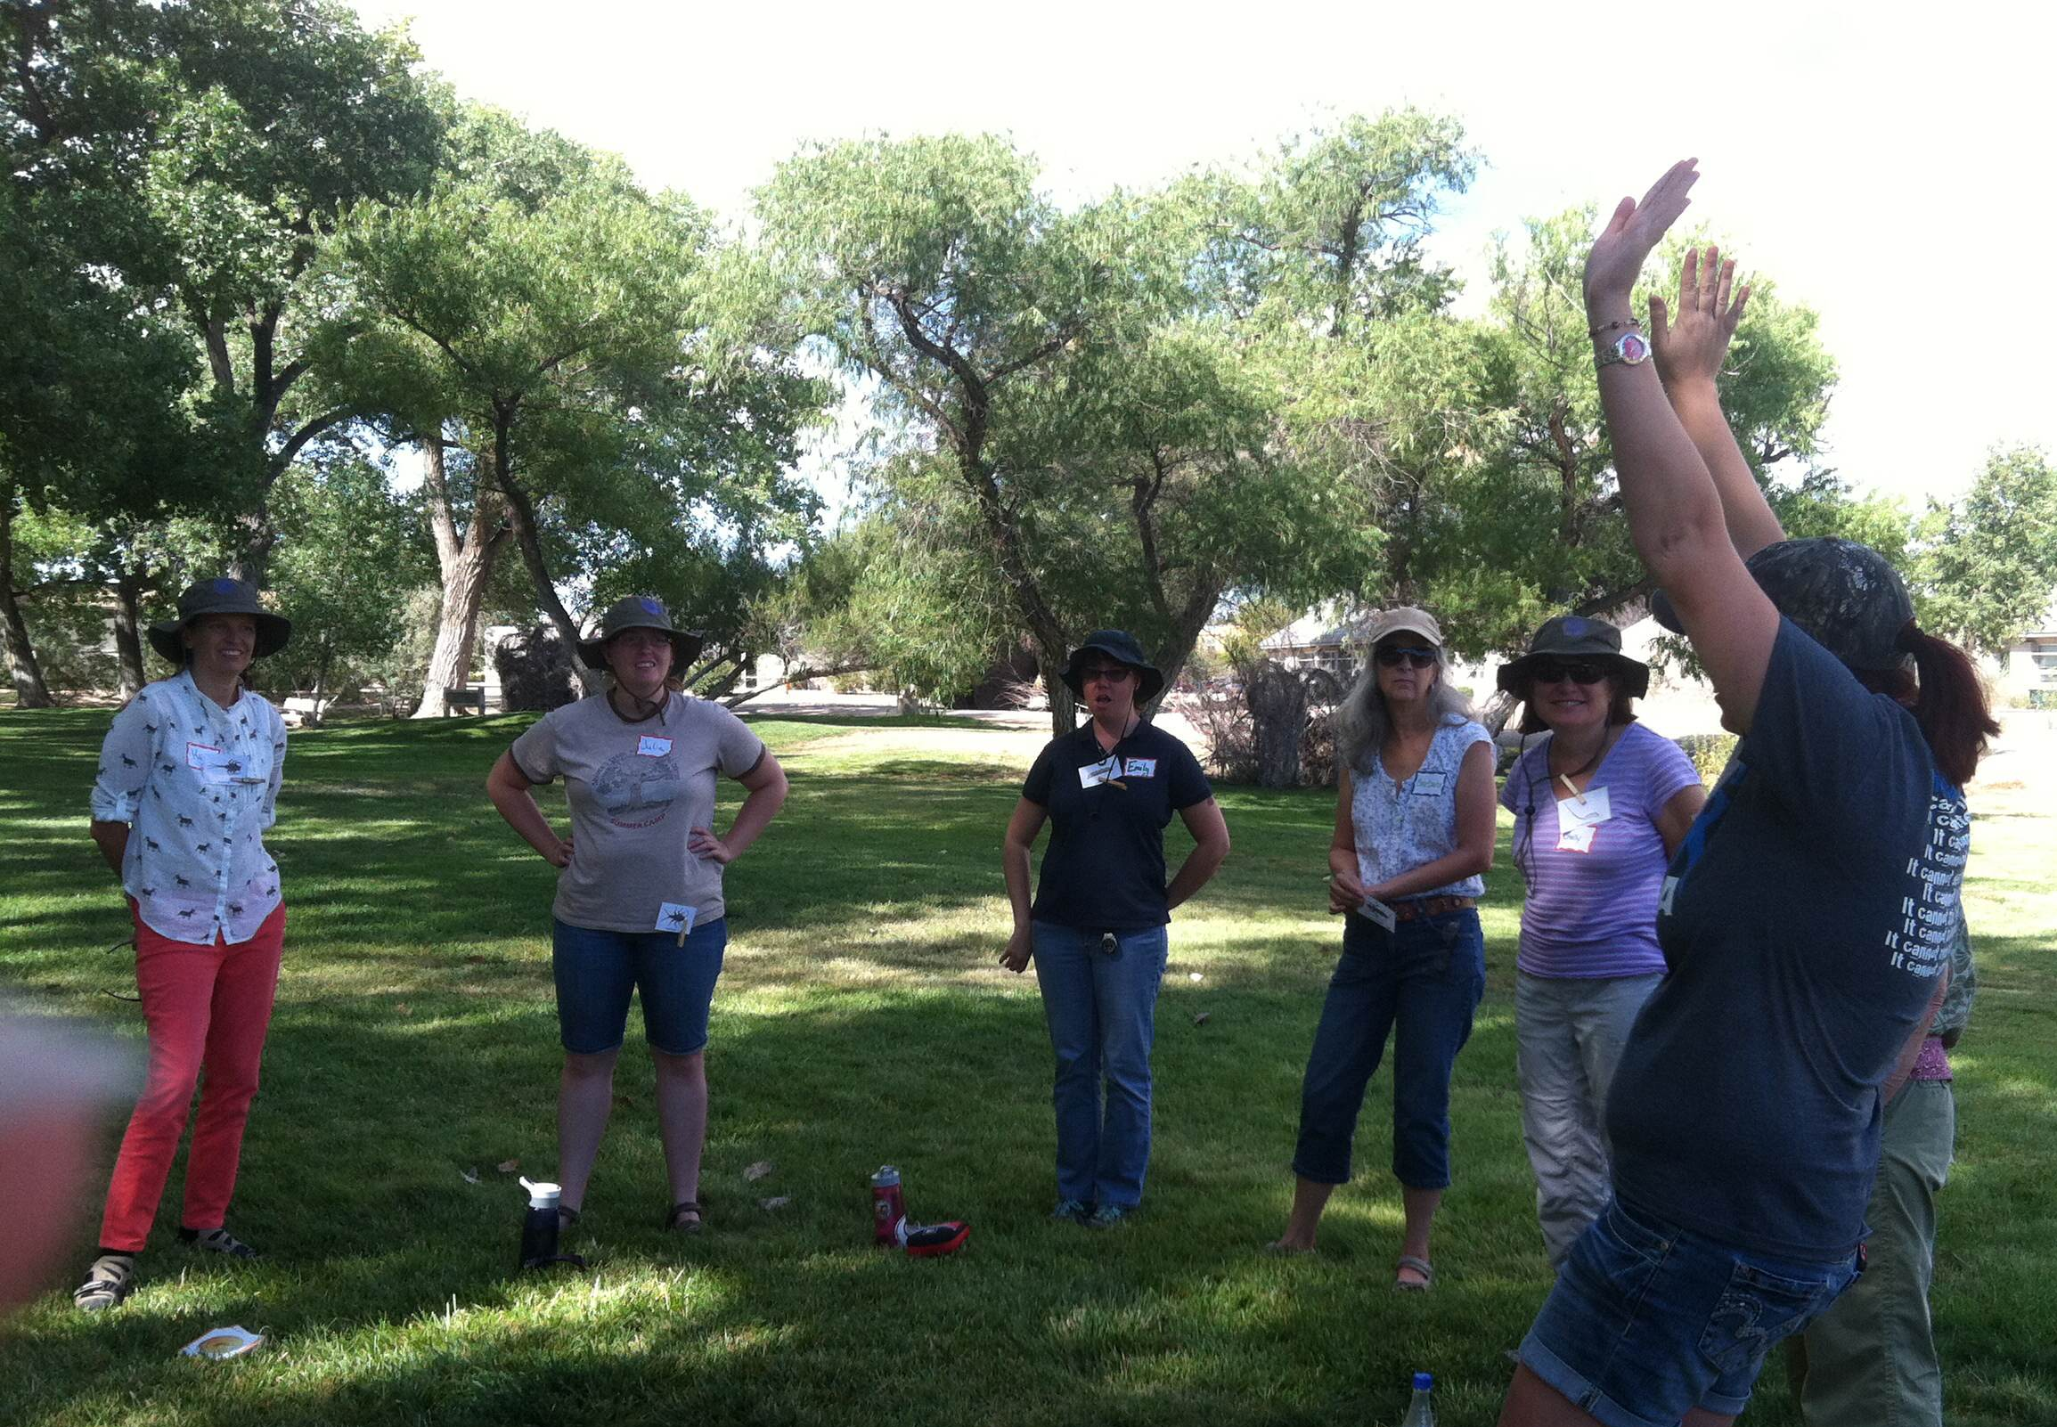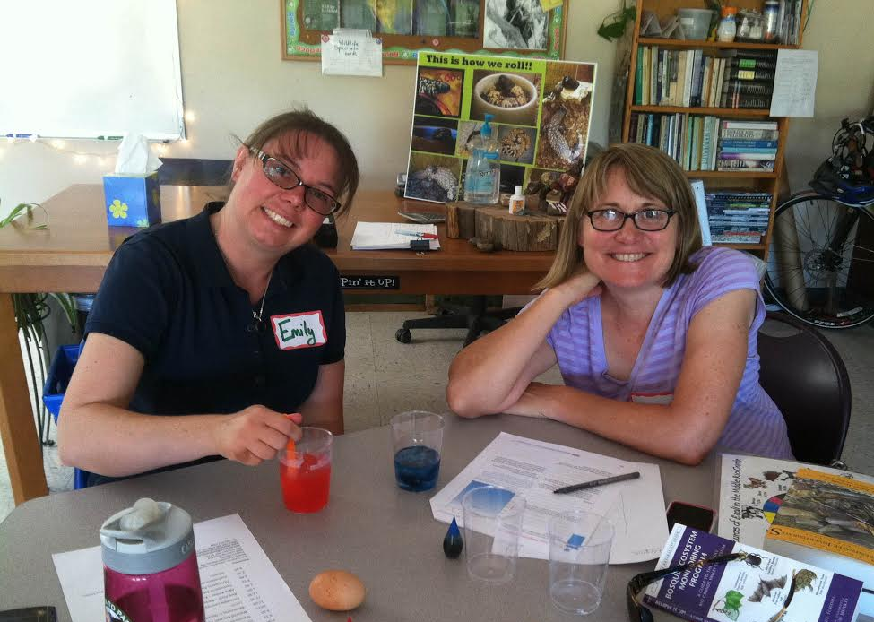

Connect with EEANM at www.eeanm.org to find out more about teachers workshops and statewide EE resources.



